**CSUEB – STAT 6305 – Winter 2017 – Prof. Yan Yan Zhou**

**Homework 3 - Henry Lankin, Gui Larangeira**

February 06, 2017

**HW 3**: 9.7a,b,c,d,e, 9.12a,b,c, 15.6a,b, 15.10a,b,c,d

9.7

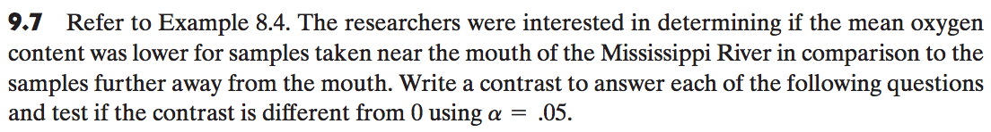

1. **Question: Is the mean oxygen content at 20 km different than the average of the mean oxygen content at 1 km, 5 km, and 10 km?**

We must test the null hypothesis:

$${H_{o}:l}_{1}=(3, -1, -1, -1)$$

From first row of Table II (AOV Linear Contrast Analysis), we find the p-value is small enough to reject the $H_{o}$ and we conclude that the mean oxygen content at 20km is different from the average of the others.

1. **Question: Is the mean oxygen content at 10 km different than the average of the mean oxygen content at 1 km and 5 km?**

Likewise, we test the $H_{o}$ and conclude by examining the second row of Table II that the oxygen content at 10km is different than the average of those at 1 and 5km.

$${H_{o }:l}_{2}=(0, 2, -1, -1)$$

1. **Question: Is the mean oxygen content at 5 km different than the average of the mean oxygen content at 1 km?**

Again, Table II row 3 supports the falsehood of the null and we accept the alternative hypothesis that the $O_{2 }$ content at 5 and 1km are different at the proposed significance level.

$${H_{o}: l}_{3}=(0, 0, 1, -1)$$

1. **Are the three contrasts defined above mutually orthogonal?**

We have,

$$l_{1}∙l_{2}=\left(3\right)\left(0\right)+\left(-1\right)\left(2\right)+\left(-1\right)\left(-1\right)+\left(-1\right)\left(-1\right)=0$$

$$l_{2}∙l_{3}=\left(0\right)\left(0\right)+\left(2\right)\left(0\right)+\left(1\right)\left(-1\right)+\left(-1\right)\left(-1\right)=0$$

$$l_{1}∙l_{3}=\left(3\right)\left(0\right)+\left(-1\right)\left(0\right)+\left(-1\right)\left(1\right)+\left(-1\right)\left(-1\right)=0$$

Since the dot product of each pair is 0, the three contrast statements are mutually orthogonal.

1. **Do the three contrasts sum of squares total to ${SS}_{TRT}$?**

From the SAS output, we have the following AOV table:

|  | **DF** | **Sum of Squares** | **Mean Square** | **F Value** | **Pr > F** |
| --- | --- | --- | --- | --- | --- |
| **Model** | 3 | 5927.60 | 1975.87 | 122.22 | <.0001 |
| **Error** | 36 | 582.00 | 16.17 |  |  |
| **Corrected Total** | 39 | 6509.60 |  |  |  |

This shows that ${SS}_{treatment}=5927.6$.

Also from the SAS output, for the contrast statements in parts (a)-(c), we have the following results,

| **Contrast** | **DF** | **Contrast SS** | **Mean Square** | **F Value** | **Pr > F** |
| --- | --- | --- | --- | --- | --- |
| **20 vs. 1, 5, 10** | 1 | 2218.80 | 2218.80 | 137.25 | <.0001 |
| **10 vs. 1, 5** | 1 | 117.60 | 117.60 | 7.27 | 0.0106 |
| **5 vs. 1** | 1 | 3591.20 | 3591.20 | 222.14 | <.0001 |

We can verify that indeed

$${SS}_{C1}+{SS}_{C2}+{SS}_{C3}=2218.8+117.6+3591.2=5927.6={SS}_{Treatment}$$

Thus, the treatment sum of squares, which has degrees of freedom 3, is broken up into 3 orthogonal sum of squares each with 1 degree of freedom.

9.12

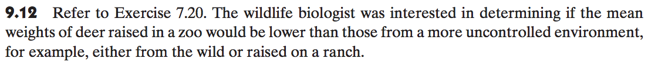

|  |  |
| --- | --- |
| **Alpha** | 0.05 |
| **Error Degrees of Freedom** | 21 |
| **Error Mean Square** | 784.02 |
| **Critical Value of Studentized Range** | 3.56 |
| **Minimum Significant Difference** | 35.29 |

1. **Use a multiple comparison procedure to determine if the mean weight of the deer raised in the wild or on a ranch is significantly higher than the mean weight of deer raised in a zoo.**

We performed both a Tukey and an LSD test in SAS, and the output is shown below:

| **Means with the same letter are not significantly different.** | | | |
| --- | --- | --- | --- |
| **Tukey Grouping** | **Mean** | **N** | **treatment** |
| A | 122.86 | 8 | wild |
| A |  |  |  |
| A | 118.39 | 8 | ranch |
| A |  |  |  |
| A | 102.88 | 8 | zoo |

Tukey Pairwise Comparison

|  |  |
| --- | --- |
| **Alpha** | 0.05 |
| **Error Degrees of Freedom** | 21 |
| **Error Mean Square** | 784.02 |
| **Critical Value of t** | 2.08 |
| **Least Significant Difference** | 29.12 |

|  |  |  |  |
| --- | --- | --- | --- |
| **Means with the same letter are not significantly different.** | | | |
| **t Grouping** | **Mean** | **N** | **treatment** |
| A | 122.86 | 8 | wild |
| A |  |  |  |
| A | 118.39 | 8 | ranch |
| A |  |  |  |
| A | 102.88 | 8 | zoo |

LSD Pairwise Comparison

We see from both multiple comparisons tests that, at the $α=0.05$ level, there is not a significant difference between the mean weight of deer raised in the zoo and those raised in the wild or on a ranch.

1. **Write a linear contrast to compare the average weight of deer raised in a zoo or on a ranch to the mean weight of deer raised in the wild.**
$$H_{o}: l=(-1, -1, 2)$$

2. **Test at the $α=0.05$ level if your contrast in (b) is significantly different from zero. What conclusions can you make from this test?**

|  |  |  |  |  |  |
| --- | --- | --- | --- | --- | --- |
| **Contrast** | **DF** | **Contrast SS** | **Mean Square** | **F Value** | **Pr > F** |
| **wild, ranch vs. zoo** | 1 | 1680.22 | 1680.22 | 2.14 | 0.1580 |

At a significance level of .05, given the p-value above, there is not enough evidence to support the alternative hypothesis that the mean weight of deer raised in a zoo and those raised in the wild or on a ranch are significantly different.

15.6

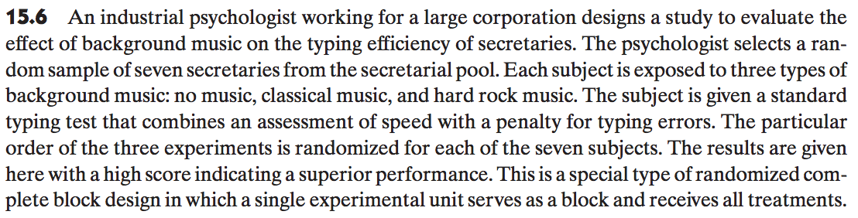

1. Write a statistical model for this experiment and estimate the parameters in your model.

Using a CRBD design with:

$y_{ij}$– the score from each test-music type combination: 21 observations

$τ_{i}$– the effect due to the type of music: 3 treatment levels

$β_{j}$– the effect due to the secretary: 7 block levels

$ε_{ij}$– random error associated with each test-music type combination: 21 residual errors

$μ$– overall score mean

**CRBD design model: $y_{ij}=μ+τ_{i}+β_{j}+ε_{ij}$**

The following table from our SAS output shows the parameter estimates for the overall mean score $\hat{μ}$, the music treatments ${\hat{τ}}_{i}$, and the subject blocks ${\hat{β}}_{j}$, with NoMusic and subject 7 set to be the base parameters:

| **Parameter** | **Estimate** |  | **Standard Error** | **t Value** | **Pr > |t|** |
| --- | --- | --- | --- | --- | --- |
| **Intercept** | 17.1904761 | B | 1.00677974 | 17.07 | <.0001 |
| **subject 1** | 3.66666667 | B | 1.25567495 | 2.92 | 0.0128 |
| **subject 2** | 0.66666667 | B | 1.25567495 | 0.53 | 0.6052 |
| **subject 3** | 7.00000000 | B | 1.25567495 | 5.57 | 0.0001 |
| **subject 4** | 2.33333333 | B | 1.25567495 | 1.86 | 0.0878 |
| **subject 5** | 4.66666667 | B | 1.25567495 | 3.72 | 0.0029 |
| **subject 6** | 7.33333333 | B | 1.25567495 | 5.84 | <.0001 |
| **subject 7** | 0.00000000 | B | . | . | . |
| **music Classical** | 2.14285714 | B | 0.82203221 | 2.61 | 0.0229 |
| **music HardRock** | -0.71428571 | B | 0.82203221 | -0.87 | 0.4019 |
| **music NoMusic** | 0.00000000 | B | . | . | . |

1. **Are there differences in the mean typing efficiency for the three types of music? Use**

$α=0.05$**.**

| **Source** | **DF** | **Type I SS** | **Mean Square** | **F Value** | **Pr > F** |
| --- | --- | --- | --- | --- | --- |
| **subject** | 6 | 149.3333333 | 24.8888889 | 10.52 | 0.0003 |
| **music** | 2 | 30.9523810 | 15.4761905 | 6.54 | 0.0120 |

The table above shows a $p$-value of $0.0120<0.05$, implying that the null hypothesis should be rejected. We conclude that there is a significant difference between the mean scores of the 3 music types.

15.10

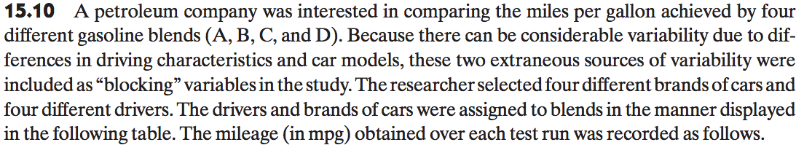

1. **Write a model for this experimental setting.**

Using a **Latin Square Design** with:

$y_{ij}$– the mpg from each driver-model-blend combination: 16 observations

$τ_{k}$– the effect due to the type of blend, where $k$ is determined by $i,j$: 4 treatment levels applied through 16 block combinations

$β_{i}$– the effect due to the driver: 4 block levels

$γ_{j}$– the effect due to the model: 4 block levels

$ε_{ij}$– random error associated with each driver-model-blend combination: 16 residual errors

$μ$– overall mpg mean

**Latin squares design model: $y_{ij}=μ++β_{i}+γ_{j} +τ_{k}+ε_{ij}$**

1. **Estimate the parameters in the model.**

The following table shows the parameter estimates for the overall mpg mean $\hat{μ}$, the blend treatments ${\hat{τ}}_{ij}$, the driver blocks ${\hat{β}}_{i}$, and the model blocks ${\hat{γ}}_{j}$.

| **Parameter** | **Estimate** |
| --- | --- |
| **Intercept** | 27.2625 |
| **driver 1** | 0.6000 |
| **driver 2** | -1.37500 |
| **driver 3** | -0.05000 |
| **driver 4** | 0.000000 |
| **model 1** | -11.77500 |
| **model 2** | 5.7000000 |
| **model 3** | -8.350000 |
| **model 4** | 0.0000000 |
| **blend A** | -0.950000 |
| **blend B** | 1.5250000 |
| **blend C** | -5.40000000 |
| **blend D** | 0.0000000 |

1. **Conduct an analysis of variance. Use $α=0.05$**.

We start by including the boxplots of the data for sake of a quick visual examination:

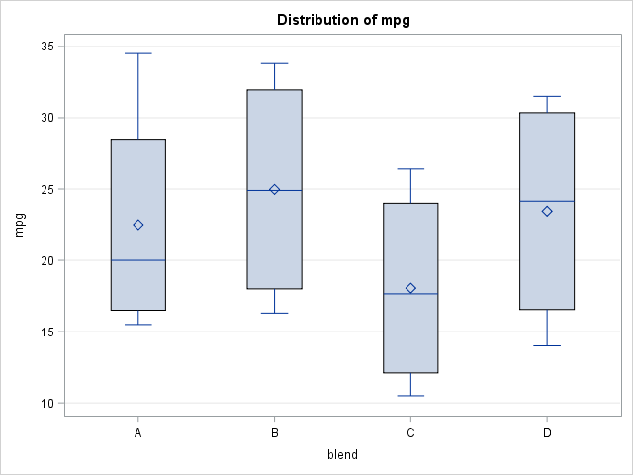

The following tables shows the results of the ANOVA test on the Latin squares design.

| **Source** | **DF** | **Sum of Squares** | **Mean Square** | **F Value** | **Pr > F** |
| --- | --- | --- | --- | --- | --- |
| **Model** | 9 | 869.975625 | 96.6639583 | 22.42 | 0.0006 |
| **Error** | 6 | 25.8637500 | 4.3106250 |  |  |
| **Corrected Total** | 15 | 895.839375 |  |  |  |

| **R-Square** | **Coeff Var** | **Root MSE** | **mpg Mean** |
| --- | --- | --- | --- |
| 0.971129 | 9.333878 | 2.076204 | 22.24375 |

| **Source** | **DF** | **Type I SS** | **Mean Square** | **F Value** | **Pr > F** |
| --- | --- | --- | --- | --- | --- |
| **driver** | 3 | 8.3318750 | 2.7772917 | 0.64 | 0.6143 |
| **model** | 3 | 755.371875 | 251.7906250 | 58.41 | <.0001 |
| **blend** | 3 | 106.271875 | 35.4239583 | 8.22 | 0.0151 |

From the AOV tables above, the $p$-value of 0.0006 shows that the model does explain the variability in the data with significance. Further, we see from the $p$-values of $0.6143, 0.0001,$ and $0.0151$ for the driver block, model block and blend treatment, respectively, that the driver block does not have a significant effect on mean mpg while the model block and blend treatment does have a significant effect on the mean mpg.

At a significance level of .05, we are only able to determine a worst performing blend, C, while all the others, A, B and D are not significantly different.

Next, we check the model assumptions.

* For equal variance:

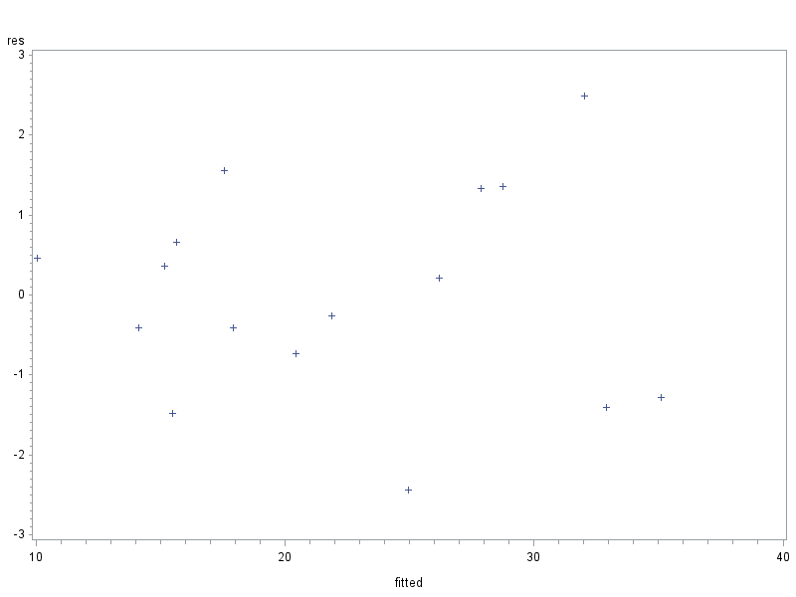

The above graph shows residual values vs. fitted values. There is no distinct pattern signifying equal variances. To examine further, we run a Levene variance test on a one-way ANOVA with blend as the treatment we get the results:

|  |  |  |  |  |  |
| --- | --- | --- | --- | --- | --- |
| **Levene's Test for Homogeneity of mpg Variance ANOVA of Squared Deviations from Group Means** | | | | | |
| **Source** | **DF** | **Sum of Squares** | **Mean Square** | **F Value** | **Pr > F** |
| **blend** | **3** | **532.3** | **177.4** | **0.11** | **0.9538** |
| **Error** | **12** | **19712.0** | **1642.7** |  |  |

The table above shows a $p$-value of $0.9538>0.05$, implying that we fail to reject the null hypothesis of equal variances. Thus, there is significant evidence to conclude that the variances are equal.

* Normality of residuals:

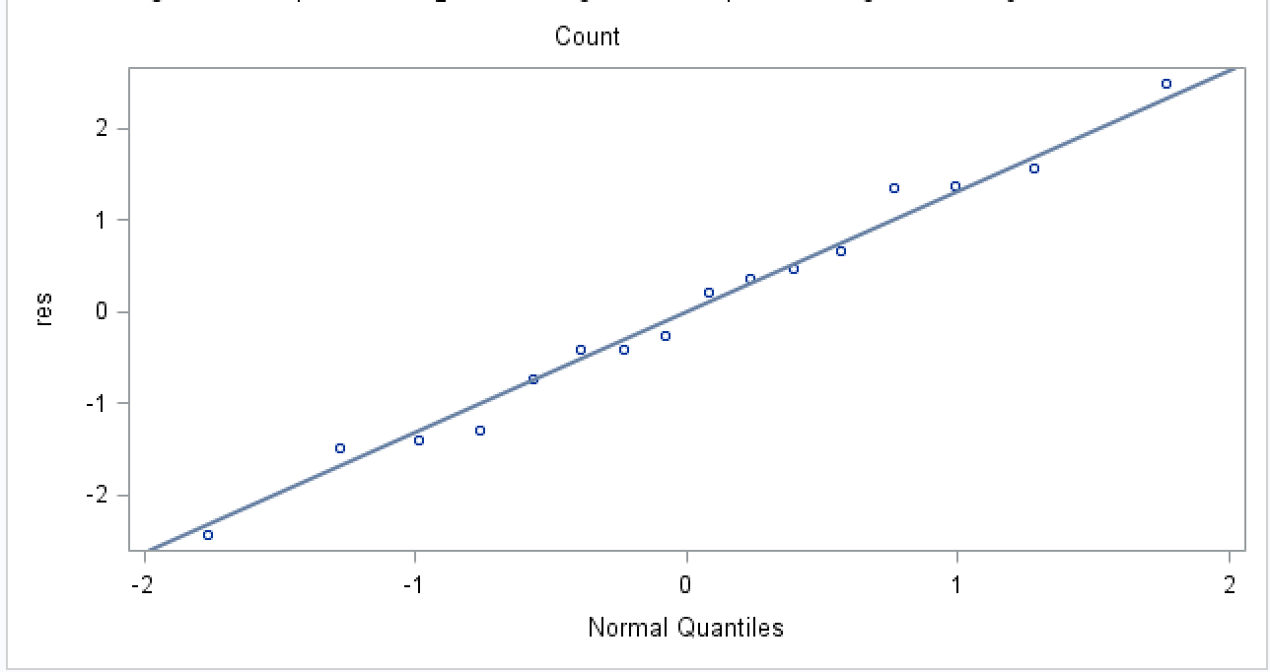

|  |  |  |  |  |
| --- | --- | --- | --- | --- |
| **Tests for Normality** | | | | |
| **Test** | **Statistic** | | **p Value** | |
| **Shapiro-Wilk** | **W** | **0.985159** | **Pr < W** | **0.9915** |

The residuals QQ-plot shows little deviation of the residuals from the regression line. Further, the Shapiro-Wilk test results in a $p$-value of $0.9915,$ further corroborating our initial impression of no significant departure from normality.

* Independence:

Both the driver and models can be reasonably assumed to be selected independently of each other.

1. **What conclusions can you draw concerning the best gasoline blend?**

The AOV results show a $p$-value of $0.0151<0.05$, implying that there is significant evidence that blend has an effect on mpg. From the parameters in part (b), blend B has the highest positive estimation of the mpg difference from blend D. This suggests that blend B may be the best gasoline blend.

Running Fisher’s LSD and Tukey’s HSD multiple comparisons test for further investigation, we have

|  |  |  |  |
| --- | --- | --- | --- |
| **Means with the same letter are not significantly different.** | | | |
| **t Grouping** | **Mean** | **N** | **blend** |
| **A** | **24.975** | **4** | **B** |
| **A** |  |  |  |
| **A** | **23.450** | **4** | **D** |
| **A** |  |  |  |
| **A** | **22.500** | **4** | **A** |
|  |  |  |  |
| **B** | **18.050** | **4** | **C** |

|  |  |
| --- | --- |
| **Fisher LSD test** | |
| **Alpha** | **0.05** |
| **Error Degrees of Freedom** | **6** |
| **Error Mean Square** | **4.310625** |
| **Critical Value of t** | **2.44691** |
| **Least Significant Difference** | **3.5923** |

|  |  |  |  |  |
| --- | --- | --- | --- | --- |
| **Means with the same letter are not significantly different.** | | | | |
| **Tukey Grouping** | | **Mean** | **N** | **blend** |
|  | **A** | **24.975** | **4** | **B** |
|  | **A** |  |  |  |
|  | **A** | **23.450** | **4** | **D** |
|  | **A** |  |  |  |
| **B** | **A** | **22.500** | **4** | **A** |
| **B** |  |  |  |  |
| **B** |  | **18.050** | **4** | **C** |

|  |  |
| --- | --- |
| **Tukey HSD test** | |
| **Alpha** | **0.05** |
| **Error Degrees of Freedom** | **6** |
| **Error Mean Square** | **4.310625** |
| **Critical Value of Studentized Range** | **4.89559** |
| **Minimum Significant Difference** | **5.0821** |

Both tests show a significant difference in mean mpg between blend C and blends B and D, while not showing a significant difference between blends B, D and A. While blend B does have the highest mean mpg, it is not possible to conclude with significance that blend B is the best gasoline blend.

SAS code:

* ex 19.7;

* input data;

**data** oxycontent;

input sample dist1 dist5 dist10 dist20;

cards;

1 1 4 20 37

2 5 8 26 30

3 2 2 24 26

4 1 3 11 24

5 2 8 28 41

6 2 5 20 25

7 4 6 19 36

8 3 4 29 31

9 0 3 21 31

10 2 3 24 33

;

**run**;

* print oxycontent data;

**proc** **print** data=oxycontent;

**run**;

* turn oxycontent data into a stacked table;

**data** oxycontent_flat; set oxycontent;

length treatment $**10**;

treatment = "dist1"; content = dist1; output;

treatment = "dist5"; content = dist5; output;

treatment = "dist10"; content = dist10; output;

treatment = "dist20"; content = dist20; output;

keep content treatment;

**run**;

**proc** **print** data=oxycontent_flat;

**run**;

* run glm procedure on stacked table;

* run contrast statement test for the 3 mutually orthogonal contrast statements;

**proc** **glm** data=oxycontent_flat;

class treatment;

model content = treatment;

means treatment /deponly;

contrast '20 vs. 1, 5, 10' treatment **3** -**1** -**1** -**1**;

contrast '10 vs. 1, 5' treatment **0** **2** -**1** -**1**;

contrast '5 vs. 1' treatment **0** **0** **1** -**1**;

**run**;

**quit**;

* ex9.12;

* input data unstacked;

**data** deersize;

input wild ranch zoo;

cards;

114.7 120.4 103.1

128.9 91.0 90.7

111.5 119.6 129.5

116.4 119.4 75.8

134.5 150.0 182.5

126.7 169.7 76.8

120.6 100.9 87.3

129.59 76.1 77.3

;

**run**;

**proc** **print** data=deersize;

**run**;

* convert deersize to stacked table;

**data** deersizeflat; set deersize;

treatment = "wild"; size = wild; output;

treatment = "ranch"; size = ranch; output;

treatment = "zoo"; size = zoo; output;

keep size treatment;

**run**;

**proc** **print** data=deersizeflat;

**run**;

* run anova test for H0: treatment means are equal;

* run multiple comparisons test -- LSD and Tukey;

* test contrast statement (-1,-1,2);

**proc** **glm** data=deersizeflat;

class treatment;

model size = treatment;

means treatment / lsd;

means treatment / tukey;

means treatment / deponly;

contrast 'wild,ranch vs. zoo' treatment -**1** -**1** **2**;

**run**;

**quit**;

* ex 15.6

* input data;

**data** typing;

input subject music :$10. score;

cards;

1 NoMusic 20

2 NoMusic 17

3 NoMusic 24

4 NoMusic 20

5 NoMusic 22

6 NoMusic 25

7 NoMusic 18

1 HardRock 20

2 HardRock 18

3 HardRock 23

4 HardRock 18

5 HardRock 21

6 HardRock 22

7 HardRock 19

1 Classical 24

2 Classical 20

3 Classical 27

4 Classical 22

5 Classical 24

6 Classical 28

7 Classical 16

;

**run**;

**proc** **print** data=typing;

**run**;

* calculate means by music (treatment);

**proc** **means** data = typing;

class music;

var score;

output out = music_means mean = ;

**run**;

* calculate means by subject (block);

**proc** **means** data = typing;

class subject;

var score;

output out = subject_means mean = ;

**run**;

* run anova test;

* estimate parameters of the model;

**proc** **glm** data = typing;

class subject music;

model score = subject music / solution;

output out=residuals r=res;

**run**;

**quit**;

**proc** **print** data=residuals;

**run**;

* ex 15.10;

* input data;

**data** mpgblend;

input driver$ model$ blend$ mpg;

cards;

1 1 A 15.5

2 1 B 16.3

3 1 C 10.5

4 1 D 14

1 2 B 33.8

2 2 C 26.4

3 2 D 31.5

4 2 A 34.5

1 3 C 13.7

2 3 D 19.1

3 3 A 17.5

4 3 B 19.7

1 4 D 29.2

2 4 A 22.5

3 4 B 30.1

4 4 C 21.6

;

**run**;

**proc** **print** data = mpgblend;

**run**;

* run glm procedure for anova test;

* estimate parameters of the model;

* output residuals res and fitted values p;

**proc** **glm** data = mpgblend;

class driver model blend;

model mpg = driver model blend / solution;

means blend / lsd;

means blend / tukey;

output out=residuals r=res p=fitted;

**run**;

**quit**;

* plot residuals vs. fitted values;

**proc** **gplot** data=residuals;

plot res*fitted;

**run**;

**quit**;

* anova test is "faked" into one-way to run levene variance test;

/**

proc glm data = mpgblend;

class blend;

model mpg = blend;

means blend / hovtest=levene;

run;

quit;

*/